INCLUSIVE LEARNING-MATERIAL SELECTION UNDER BUDGET
Java Implementation Using 0/1 Knapsack Algorithm
1. ABSTRACT
The project uses the 0/1 Knapsack Dynamic Programming algorithm to find the optimal selection of materials. Each learning material has a name, cost and accessibility-benefit score. The program also implements a Greedy algorithm for comparison and a Brute Force approach to verify the results for small test cases.
The system is developed using Java programming language. It displays the selected materials, total cost, maximum accessibility benefit and comparison results.
This project demonstrates how algorithmic techniques can support better utilization of educational resources and promote inclusive learning.
2. INTRODUCTION
Education is an important right for every individual. Inclusive education ensures that all students get equal opportunities to learn, regardless of their abilities or learning requirements.
Some students require special learning materials such as Braille Learning Kits, Audio Learning Resources, Accessible Learning Software, Educational Laptops and Screen Reading Tools.
However, schools and educational institutions may have limited financial resources. Purchasing all available materials may not be possible.
To solve this problem, our project uses an optimization technique called the 0/1 Knapsack Problem. Dynamic Programming is used to obtain the optimal solution, while Greedy and Brute Force algorithms are used for comparison and verification.
3. PROBLEM STATEMENT
The main problem is to select a combination of inclusive learning materials under a limited budget while maximizing the total accessibility benefit.
Each learning material has a unique name, a purchasing cost and an accessibility-benefit score.
The system must select materials in such a way that:
1. The total cost does not exceed the available budget.
2. The total accessibility benefit is maximized.
3. Each material is selected at most once.
4. The selected materials are displayed clearly.
This problem is solved using the 0/1 Knapsack Dynamic Programming algorithm.
4. OBJECTIVES
The main objectives of this project are:
1. To develop a Java-based learning-material selection system.
2. To accept material names, costs and accessibility benefits.
3. To implement the 0/1 Knapsack algorithm using Dynamic Programming.
4. To maximize accessibility benefits within the given budget.
5. To compare Dynamic Programming with the Greedy approach.
6. To verify small test cases using Brute Force.
7. To analyze the time and space complexity of the algorithms.
8. To support better resource allocation for inclusive education.

5. ALGORITHM
Our project uses three algorithms.
- Dynamic Programming – 0/1 Knapsack
Dynamic Programming is used to find the maximum accessibility benefit within the available budget.
- Steps:
1. Read the number of learning materials.
2. Read the name, cost and benefit of each material.
3. Read the total available budget.
4. Create a DP table.
5. Check whether each material can fit within the current budget.
6. Calculate the maximum benefit by selecting or skipping the material.
7. Store the maximum benefit in the DP table.
8. Trace the table to identify selected materials.
9. Display the total cost and maximum benefit.
- Greedy Algorithm
The Greedy algorithm selects materials based on their benefit-to-cost ratio.
- Steps:
1. Calculate the benefit-to-cost ratio for every material.
2. Sort the materials in descending order of the ratio.
3. Select the material with the highest ratio if it fits within the remaining budget.
4. Continue until no more materials can be selected.
5. Display the selected materials and total benefit.
- Brute Force Algorithm
Brute Force checks every possible combination of learning materials.
- Steps:
1. Generate all possible subsets of materials.
2. Calculate the total cost of each subset.
3. Calculate the total accessibility benefit.
4. Ignore subsets that exceed the budget.
5. Identify the subset with maximum benefit.
6. Compare the result with Dynamic Programming.
6. FLOWCHART
START
↓
Enter number of learning materials
↓
Enter material name, cost and accessibility benefit
↓
Enter total budget
↓
Apply Dynamic Programming (0/1 Knapsack)
↓
Display selected materials and maximum benefit
↓
Apply Greedy Algorithm
↓
Verify using Brute Force
↓
Compare DP and Brute Force results
↓
Display verification status and complexity
↓
END
7. METHODOLOGY
The project follows a systematic approach to select learning materials based on cost and accessibility benefit.
- Step 1: Input Collection
The user enters the number of learning materials and provides the name, cost and accessibility benefit of each material.
- Step 2: Budget Input
The user enters the total available budget for purchasing learning materials.
- Step 3: Dynamic Programming Implementation
The system creates a DP table and calculates the maximum possible accessibility benefit without exceeding the budget.
- Step 4: Greedy Implementation
The program sorts materials according to their benefit-to-cost ratio and selects materials based on the remaining budget.
- Step 5: Brute Force Verification
The program checks possible combinations and compares the maximum benefit with the Dynamic Programming result.
- Step 6: Result Generation
Finally, the system displays the selected materials, total cost, maximum benefit and algorithm comparison.
8. RESULTS
The Java program accepts material names, costs, accessibility benefits and the total budget.
The following sample values are used to demonstrate the project.

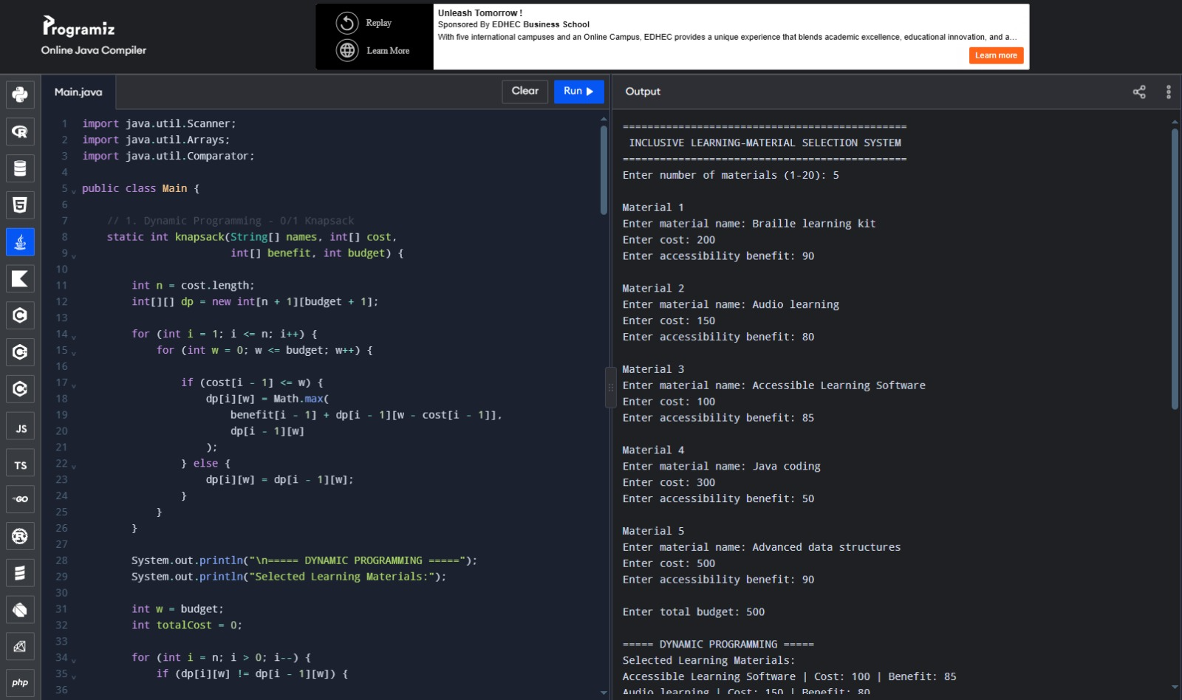
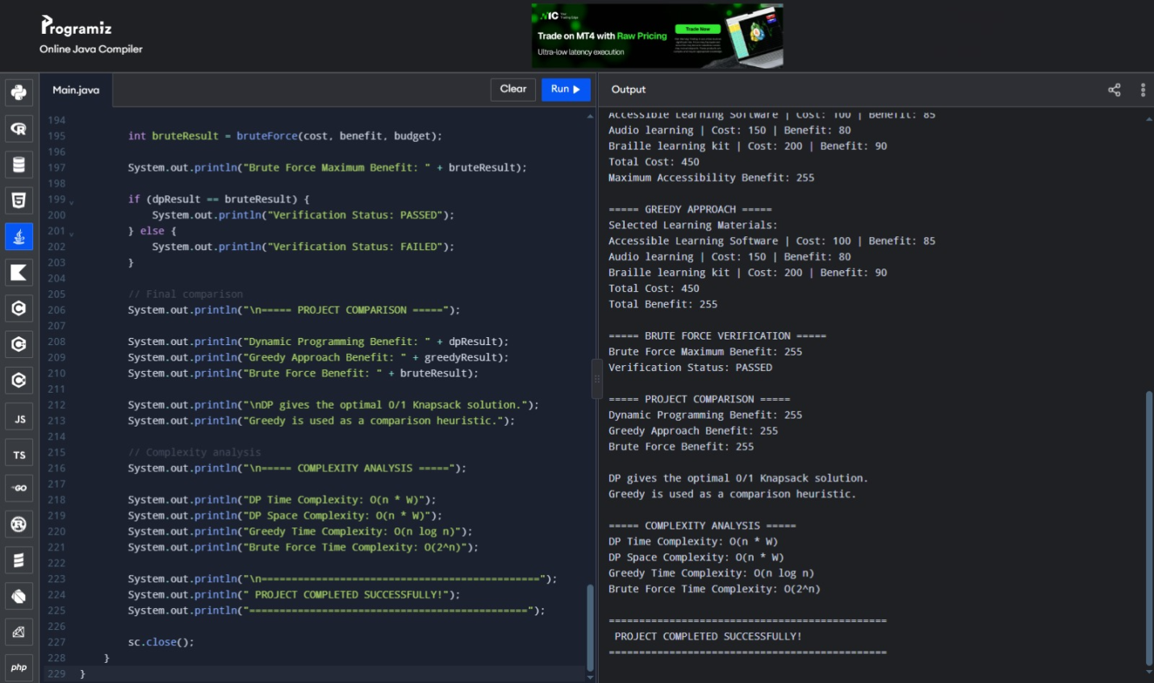
10. COMPLEXITY ANALYSIS
Complexity analysis explains how much time and memory each algorithm requires.
- Dynamic Programming:
Time Complexity: O(n × W)
Space Complexity: O(n × W)
- Greedy Algorithm:
Time Complexity: O(n log n)
Space Complexity: O(n)
- Brute Force:
Time Complexity: O(n × 2ⁿ)
Auxiliary Space Complexity: O(1)
Where:
n = Number of learning materials , W = Total available budget.
11. INCLUSIVE EDUCATION AND EQUITY
Inclusive education focuses on providing equal learning opportunities to students with different abilities and learning requirements.This project supports inclusive education by demonstrating how limited financial resources can be allocated to accessible learning materials.
- For example:
1. Braille kits support students with visual impairments.
2. Audio resources provide alternative learning formats.
3. Accessible software can support learners who use assistive technologies.
4. Educational laptops provide access to digital learning resources.
The project demonstrates a decision-support model. In real-world applications, accessibility scores should be determined with input from students, teachers and accessibility experts.
12. CONCLUSION
The Inclusive Learning-Material Selection Under Budget project provides an algorithmic solution for selecting accessible educational resources under a limited budget.
The project implements the 0/1 Knapsack problem using Dynamic Programming to identify the optimal combination of materials.
The Greedy algorithm is used for comparison, while Brute Force verifies the optimal result for small test cases.
The project demonstrates how Java programming and optimization algorithms can help improve educational resource allocation and support inclusive learning.
13. FUTURE WORK
The project can be improved in several ways:
1. Develop a graphical user interface for easier interaction.
2. Integrate a database to store learning-material details.
3. Add more accessibility categories and evaluation criteria.
4. Generate downloadable selection reports.
5. Develop a web-based application for schools and educational institutions.
6. Include multiple budget categories and learner requirements.

